Nama : Aulia Faiqoh
NIM : 2304020032
No. Urut : 27
Data Student Performance
https://docs.google.com/spreadsheets/d/1i6aQuI7_8mOihmxWbNlIYamoxb1xCslQT0a46iWSCjk/edit?usp=sharing
Sintaks untuk menampilkan data dan diagram lingkaran:
import pandas as pd
import matplotlib.pyplot as plt

df=pd.read_csv('/content/drive/MyDrive/StudentsPerformance.csv')

from google.colab import drive
drive.mount('/content/drive')

df.head()

data_pie = df["lunch"].value_counts()

plt.figure(figsize=(10, 10))
plt.pie(
data_pie.values,
labels=data_pie.index,
autopct='%1.1f%%'
)

plt.title("Diagram Lingkaran lunch")
plt.show()
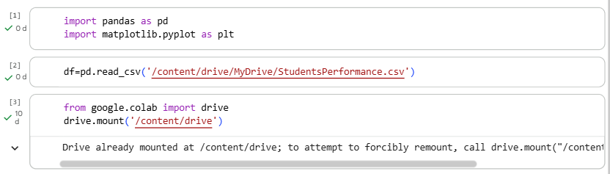
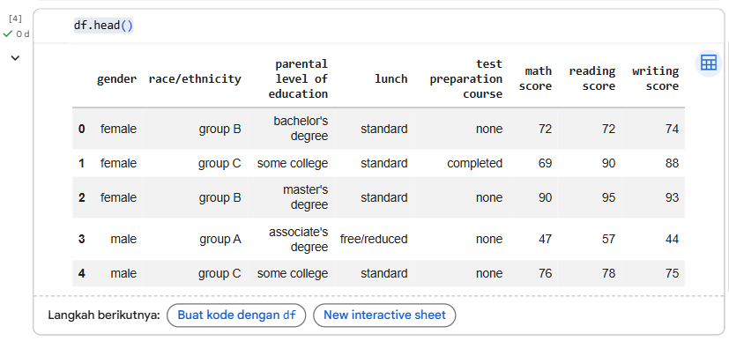
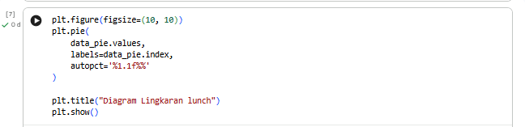
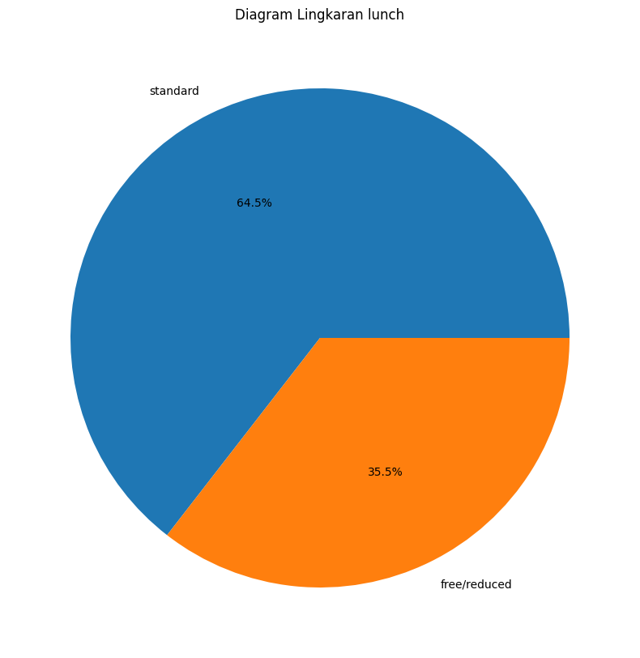

Data Basis Data Pangan & Gizi Global
https://docs.google.com/spreadsheets/d/1hSsEzVt_JyRru_bV5Q1JMR7hnUkpawA76hHNqSnLCU/edit?usp=sharing
Sintaks untuk menampilkan data dan diagram lingkaran:
import pandas as pd
import matplotlib.pyplot as plt

df=pd.read_csv('/content/drive/MyDrive/comprehensive_foods_usda.csv')

from google.colab import drive
drive.mount('/content/drive')

df.head()

data_pie = df["food_type"].value_counts()

plt.figure(figsize=(10, 10))
plt.pie(
data_pie.values,
labels=data_pie.index,
autopct='%1.1f%%'
)
plt.title("Diagram Lingkaran food type")
plt.show()

